Proposed Updates to the AAGI Style Guide

Report for AAGI-AU-RD-WOP Milestone #1

Prepared by: **Sam Rogers**, Adam Sparks, Robert Armstrong, Russell Edson, Kristina Gagalova,  
Javier Fernandez, Wasin Pipattungsakul, Sebastian Lopez Marcano

Correspondence email: [sam.rogers@adelaide.edu.au](mailto:sam.rogers@adelaide.edu.au)

Last updated: 27 June 2025

**Contents**

Purpose of Report 1

Recommendations for Improved AAGI Branding/Template Adoption 1

Updates Regarding AAGI Logo and Logo Block Usage 3

Considerations for Font and Format for AAGI Publications 5

Proposals for Improved Consistency of AAGI Reporting 7

Conclusion 10

**Annexures**

Annexure 1 - AAGI_logo_guidelinesV1.pdf

# Purpose of Report

In accordance with Milestone #1 of the GRDC-funded AAGI research project AAGI-AU-RD-WOP, a review has been made of the existing *AAGI Style/Logo Guide* (refer to Annexure 1, attached with this report submission). This report documents critiques and suggested improvements for the style guide, based on the prior work of the templating effort of the AAGI Strategic Partners in 2024, together with consultation of the experiences from AAGI analysts and researchers across the 2.5 years of the project’s runtime.

The AAGI Style Guide improvements are proposed to achieve two desirable aims:

1. To bring the style guide, and the adoption of it by AAGI personnel, into improved alignment with AAGI’s expectations for brand consistency and professional quality of publications and other project outputs.
2. To set the framework for the further development of the AAGI reporting templates, which are designed to empower AAGI analysts and researchers to effortlessly adhere to the style guidelines in their work.

The recommendations of this report are put forth to the AAGI Leadership for further consideration.

# Recommendations for Improved AAGI Branding/Template Adoption

**Improve Awareness of Correct Use of AAGI Branding and Templates**      There are still many AAGI analysts and researchers that do not use the templates or adhere to the AAGI branding guidelines when producing publications and other material outputs for their projects. After consulting with some of these AAGI personnel, it is apparent that there is still much ambiguity about what an “AAGI output” is, when the logo/style guide should apply, and the limits regarding customisation of the templates. For example,

* One researcher, when asked about why there were not using the AAGI Presentation template, insisted that the “template was for AAGI Symposiums or AAGI Internal Presentations only” and refused to use the correct template for their conference presentation, instead opting for a modified AAGI presentation slide format that omitted the Strategic Partner logo block entirely. (Figure 1 shows a redacted version of the title slide used for their presentation.)
* Another researcher, when asked about why they were not using the Project Partner variant of the logo block (instead, opting to have the Project Partner logo flush with the AAGI logo in the top-right corner) in their presentation, argued that they thought it “was not being kind [sic] to the Project Partner” to have them in the logo block with the Strategic Partners across the bottom of the title page, and refused to make the change to use the correct logo block.
* A third researcher, asked about why they were not using the correct template for their report, admitted that they did not know where to find the AAGI templates that they should be using for reporting and that they were not very familiar with navigating GitHub.

Some of the AAGI personnel appear to treat the templates and the AAGI branding guidelines as a ‘suggestion’, rather than a stipulation. It is a recommendation of this report that the Style Guide be updated so that it is clear about when its guidelines should apply (i.e., *always*, to all AAGI reports, presentations and outputs), with emphatic directions from the AAGI leadership to use the AAGI branding and templates correctly for all project work, to ensure the consistency and quality of AAGI’s branding and professional image.

Figure 1: Title slide used for a presentation of AAGI project work at a recent 2025 conference, in violation of the AAGI logo usage guidelines and presentation template. (The presenter’s name, presentation title, affiliations and the Project Partner logo have been redacted in the interests of discretion.)

# Updates Regarding AAGI Logo and Logo Block Usage

**Update Logo Description in Style Guide**Page 2 of the AAGI Logo/Style Guide refers to the light green part of the AAGI logo as a “wheat sheaf”, but it is actually a *wheat ear* (see Figure 2). This terminology should be corrected in future revisions of the style guide. Additionally, references to the “University of Adelaide” will need to be updated to be references to *Adelaide University* for 2026 and beyond.

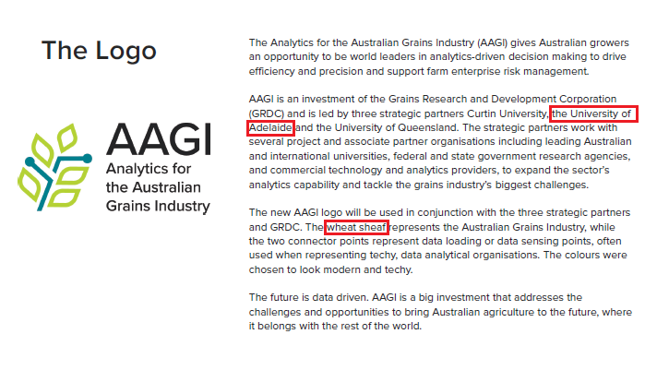

Figure 2: Page 2 of the AAGI Logo/Style Guide should be updated in future revisions to correctly refer to the wheat ear (rather than wheat sheaf), and to replace references to University of Adelaide with Adelaide University.

**Update to Use Adelaide University Logo for 2026**The University of Adelaide’s merger with the University of South Australia is concluding imminently, with Adelaide University set to “go live” on the 1st of January, 2026. In the latter half of 2025, both universities are wrapping up their separate operations and updating their communications and business materials to use the new Adelaide University branding.[1]

In turn, much of the AAGI templates and other promotional material that uses the logo block will need to be updated (including printed promotional materials, signage and banners, such as the one depicted in Figure 3). The old University of Adelaide logo must be replaced with the new Adelaide University logo, which will require approvals from the Adelaide University Marketing team as well as adherence to their new logo printing and spacing requirements.

**Fix Inconsistent Colours in AAGI Logo Assets**The AAGI Logo/Style Guide is specific about the HTML colour codes used for the AAGI theme colours and logo colours: #00808b for the teal main colour, #b6d438 for the light green accent colour, and #414042 for the lighter black colour for the title text. However, many of the logo image assets disseminated to the Strategic Partners differ in the precise HTML colours that are used (see Figure 4). Further, the precise colours used for the logo seem to differ depending on which type of image file is used (see Table 1). It is a recommendation of this report that the logo image files be checked and fixed, to ensure that they are consistent with the logo requirements as specified in the Style Guide and are also consistent with each other.

Figure 3: The AAGI banner in the AAGI Director’s office, located at the Biometry Hub offices on the University of Adelaide Waite Campus. This banner will need to be reprinted with the Adelaide University logo replacing the University of Adelaide logo. (Note that the logo for the University of Queensland is also outdated in this banner, and should be replaced with the correct logo before reprint.)

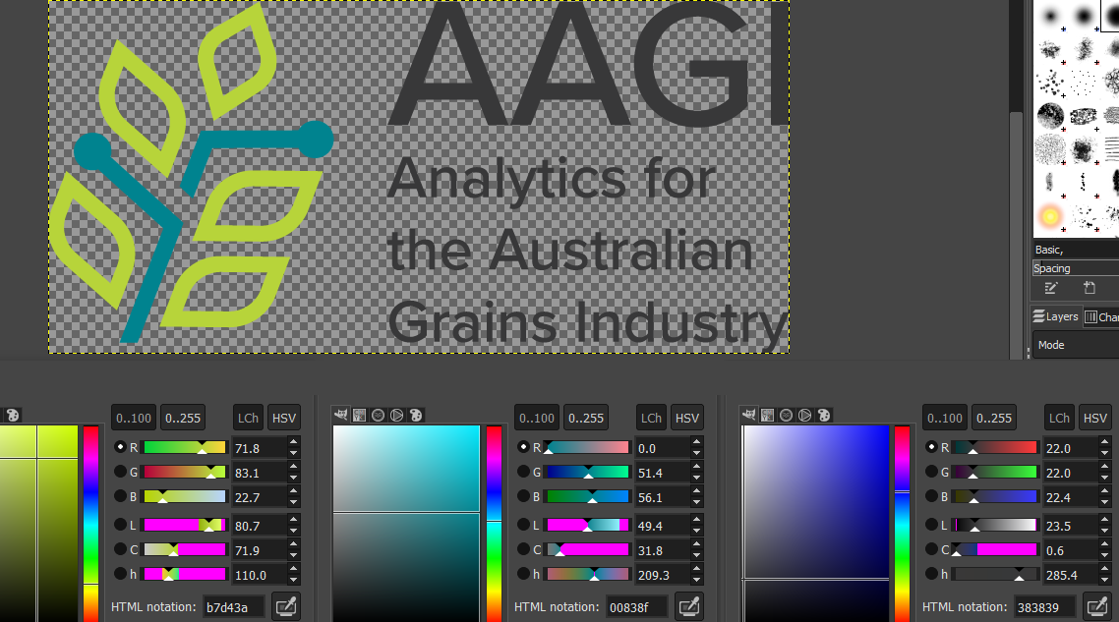

Figure 4: Colour analysis for the PNG image file for the AAGI logo (AAGI logo colour CMYK.png). The light green colour differs very slightly (it is #b7d43a, not #b6d438); the teal colour differs slightly (it is #00838f, not #00808b), and the off-black colour differs noticeably (it is #383839 not #414042, which produces a noticeably darker logo text especially when printed).

Table 1: The AAGI logo image files provided to the AAGI personnel together with their hexadecimal HTML colours. The header row includes the precise HTML colours from the style guide, which generally differ from the colours actually used by the logo assets.[2]

|  |  |  |  |
| --- | --- | --- | --- |
| Asset Filename | Teal (#00808b) | Green (#b6d438) | Black (#414042) |
| AAGI logo colour CMYK.svg | #00818d | #b7d438 | #414042 |
| AAGI logo colour CMYK.png | #00838f | #b7d43a | #383839 |
| AAGI logo colour CMYK.jpg | #00828f | #b7d43c | #383838 |
| AAGI logo colour CMYK.eps | #00818d | #b7d439 | #414042 |
| AAGI logo colour CMYK.ai | #00818d | #b7d438 | #414142 |

**Improve Clarity in Style Guide for Using AAGI Logo with Logo Block**It is a recommendation of this report that the AAGI Logo/Style Guide be updated to include the unambiguous requirement that the AAGI Logo *always* be used with the Strategic Partner logo block. Currently the style guide does not make this clear, and many AAGI personnel use the AAGI logo in presentations and other material without including the logo block.

The style guide should also be updated to advise that, when it is not possible to use both the AAGI logo as well as the Strategic Partner logo block, that the AAGI logo be *omitted entirely*. Such cases often arise when AAGI-related materials are required to use templates or branding that differ to the prepared AAGI templates. Figure 5 shows a recent example of such a case.

Figure 5: A recent example of promotional material for AAGI that was required to use a specific template from one of the Strategic Partners. In this case inclusion of the Strategic Partner logo block was not possible due to the template constraints. Instead of using the AAGI logo by itself (left), on advice from the AAGI leadership and the AAGI Director, the AAGI logo was omitted entirely (right).

# Considerations for Font and Format for AAGI Publications

**Update Style Guidelines to Include Font Sizes/Colours and Headings Usage**      The AAGI Logo/Style Guide currently has some guidance for the appearance of presentation title slides and coloured tables, but it does not have any guidance for other document elements such as font sizes, font colours, or structures for paragraphs and headings. Presumably, many of these elements are left as creative choices to the report writer. However, the AAGI Style Guide should be updated to offer some best-practice recommendations:

* Font sizes (e.g., this current report uses Size 11 for normal text and Size 14 for Section headings, but what about for presentations?)
* Font colours (e.g., should black text be used for all report headings, or should AAGI theme colours be used?)
* Headings (e.g., what typical headings should appear in each report/template, and to what extent should the report writer have creative control over what headings they use?)

The exact recommendations for these report elements should be discussed and agreed upon by the AAGI leadership. Some creative leeway is advisable and should be left to the writer’s discretion; however, providing recommendations helps to improve consistency of AAGI’s project outputs across the Strategic Partners.

**Suggest Computer Modern as a Fallback Font for AAGI Reporting**      Many of the AAGI analytics workflows generate reports using LaTeX (via RMarkdown or Quarto), and the templating effort of the Strategic Partners in 2024 has provided templates for these that contain the AAGI logo and SP logo block in the correct usage. However, getting the LaTeX engine to work with proprietary fonts such as Proxima Nova is often a fiddly and error-prone endeavour, and in most cases locks the user into using a specific engine (lualatex with fontspec) which might not work with their computer/analytics setup.

Note that an “Arial-like” font is available in LaTeX via the helvet package. However, the LaTeX default sans serif font, *Computer Modern*, requires no additional setup or modifications, works well with mathematics equation typesetting, and is a professional and aesthetically pleasing font that should be suggested as a fallback font alongside Arial.

The below examples show how each font appears in size 11(pt) sans serif text. For the Computer Modern font, a capture image has been included to show exactly how the font appears when a report is compiled to PDF from a typical analytics workflow using LaTeX (or RMarkdown/Quarto).

**Proxima Nova Medium (Size 11)**

The quick brown fox jumps over the lazy dog.

abcdefghijklmnopqrstuvwxyz

ABCDEFGHIJKLMNOPQRSTUVWXYZ

0123456789

**Arial (Size 11)**

The quick brown fox jumps over the lazy dog.

abcdefghijklmnopqrstuvwxyz

ABCDEFGHIJKLMNOPQRSTUVWXYZ

0123456789

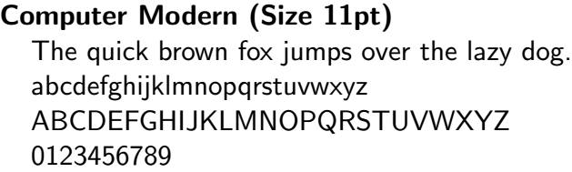

# Proposals for Improved Consistency of AAGI Reporting

**Standardise AAGI Reporting Templates**Currently there are two reporting templates used for AAGI project reporting (shown in Figure 6): a *full report template* used for main reporting by AAGI to clients and work collaborators, as well as a *short report template* intended for smaller/interim output reports. Note that these report templates were designed spontaneously as part of the AAGI standardisation and templating efforts in 2024. Outside of adherence to the logo/block requirements, the AAGI Style Guide provided little further guidance on how these reports should look.

There is currently little guidance in terms of the style and structure for these reports. In practice, many of the reporting content and style choices are left to the individual report writer, and this results in inconsistent report appearance and structure across the AAGI strategic partners. While some freedom regarding the content of each report is desirable (as this allows for report layouts to be adjusted to best suit the needs of a particular project or client), it is a recommendation of this report that the AAGI leadership consider how they would like AAGI report outputs to look, including in particular:

* Choices of font sizes and font colouring for the title page (or short report top-matter),
* The content that must appear on the title page (e.g., how the report title should look, whether to include references to Strategic Partner Project Leads, and so on).

These considerations should be discussed by the AAGI leadership, and documented as formal guidelines for reporting in the proposed update to the AAGI Style Guide.

Figure 6: The title pages used for the current AAGI reporting templates, the AAGI full report (left), and the AAGI short report (right).

**Proposal: Change Full Report Title Page Based on Project Type**As a suggestion to improve the consistency of AAGI project reporting, the full report template could have different versions depending on the type of project: for instance, there could be a template for a Service and Support project report, and then a separate template for the report for a Research and Development project. These templates would differ in their content and structure (see, for example, Figure 7):

* The *Service and Support project report* would be prepared with a target client in mind, and this could be noted on the title page of the report. In terms of structure, the client would have some influence over what details need to be included and where, but the Style Guide could propose some best-practice recommendations (such as the order of sections, inclusion of a section for Trial Design and Trial Maps, or a section for Dataset description and Metadata).
* The *Research and Development project report* would be prepared for a more general audience (or as a ‘draft form’ for a paper to be submitted to a journal article), with all research collaborators and institutions that contributed to the work referenced appropriately on the front page of the report. Each R&D report would presumably be very similar in form and structure across the Strategic Partners, and the AAGI Style Guide could suggest a more rigid set of section titles and suggested content inclusions to be used.

Similar full report types could be developed for Upskilling and Awareness reports and Consulting reports, and a similar versioning could be proposed for the short report template.

Figure 7: Proposed title pages for the AAGI Service & Support report (left) and the AAGI Research & Development report (right).

**Standardise Inclusion of Strategic Partner Project Leads**Currently there is inconsistency across the AAGI Strategic Partners regarding inclusion of project leads on report title pages:

* Curtin University includes the names of the AAGI-CU project leads on the title pages of every report as a requirement.
* University of Queensland includes only the names of personnel that were involved in the project, with no requirement for mention of AAGI-UQ project leads (unless they were involved in the work).
* University of Adelaide includes only the names of personnel that were involved in the project, with no requirement for mention of AAGI-AU project leads (unless they were involved in the work).

This report recommends that the AAGI Leadership consider whether the inclusion of project leads should be stipulated for all AAGI reporting, to be consistent in reporting across the AAGI Strategic Partners.

**Standardise AAGI Full Report Title Pages**The template for the full report title page is shown below. Note that this template was generated based on the appearance of the report title page for Statistics for the Australian Grains Industry (SAGI) projects, with little input from AAGI Leadership or the wider AAGI team. Many of the elements—such as font colours, font sizes, layout and content—have been chosen spontaneously by the team working on the AAGI templating effort. This report recommends that the AAGI Leadership team review the title page appearance and suggest modifications where necessary/desired.

**Analytics for the Australian Grains Industry**

**University of XXXXXX (AAGI-XX)**

**Service and Support Report**

**Informative Title for Report**

**Project Code: ABC1234-567XYZ**

Prepared for: **Organisation Lead**

Name 2

Name 3

Prepared by: **Your Name**

Name 2

Name 3

Correspondence email: [your.name@example.edu.au](mailto:your.name@example.edu.au)

23 June 2025

Title page elements for the Full Report Template:

* “Analytics for the Australian Grains Industry” title, in teal-coloured size 20 Proxima Nova (or fallback).
* “University title (AAGI-XX)”, in teal-coloured size 20 Proxima Nova font (or fallback).
* “Such-and-such Report”, in teal-coloured size 20 Proxima Nova font (or fallback).
* The report title, in black size 20 Proxima Nova font (or fallback), with spacing above.
* The project code, in black size 16 Proxima Nova font (or fallback).
* Authorship/audience details, in black size 12 Proxima Nova font (or fallback), with spacing:
  + For Service and Support Reports, these details include the client/organisation that the report is written for (including names for all intended recipients), with **bold typeface** used to distinguish the corresponding author/recipient.
  + For Research and Development Reports, these details include the names of all collaborators, with **bold typeface** used to distinguish the report author to which correspondence should be addressed—typically the principal investigator for the research.
  + Similar details sections would exist for Upskilling and Awareness Reports and Consulting Reports, with similar superficial differences.
* Correspondence email, in black size 12 Proxima Nova font (or fallback), with spacing.
* *(Not shown) Project lead details, in black size 12 Proxima Nova font (or fallback), with spacing.*
* Date, in black size 12 Proxima Nova font (or fallback), in the format DD Month YYYY, with spacing.

These report title page elements are open to critique and modification. (For example, should the top titles be teal-coloured, or should they be black instead?)

# Conclusion

This report puts forth these recommendations for an update to the AAGI Logo/Style Guide and improve quality of the AAGI reporting across the Strategic Partners. The benefits of these recommendations are threefold:

1. Use of the AAGI branding is made uniform across the AAGI Strategic Partners, and this consistency in reporting and project outputs improves AAGI’s image to our collaborators, partners and clients.
2. The improved guidelines set forth a clear and adoptable expectation for generating any AAGI project materials, which AAGI analysts can use to produce professional-quality outputs by adherence to the guidelines.
3. The Style Guide update sets a firm framework for the (further) development of the AAGI templates, which are designed for ease-of-use and to streamline AAGI’s reporting and analytics processes.

1. I have asked the University of Adelaide/Adelaide University Marketing team for an estimate of the timeframes, and they have responded that they plan to roll out the updates across UofA branding from *1st November 2025*. They will reach out to the AAGI-AU team directly to assist in updating the asset branding to use the new Adelaide University logo.
2. One could argue that we should be looking at the Pantone or CMYK colour spaces instead, rather than using the more precise hexadecimal HTML colours, especially given the image filenames. However, Black 90% / CMYK (0%,0%,0%,90%) maps to #191919 or thereabouts, which is nowhere near the colour that is used for the text in the AAGI logo. Therefore, it seems safe to assume that matching to the RGB/HTML colours is what is actually desired for the logo graphics. In this case, the differences between the HTML hexadecimal values across the image files are a concern.